#
Full Name
Student
Number
Conta

nature(s)
Date

Question 1
1.1 Given 10.10.0/18
/18 = 255.255.192.0
Block size = 256-192=64
Network address =10.10.0.0
Broadcast address =10.10.63.255
Number of host =32-18=14host
Total number of address= 2^14 =16;384
Usable host =16;384-2=16;382 usable
Subnet mask= 255.255.192.0
1.2
area
CWOP
Host
520
Network
10.10.0.0
Preﬁx
/22
Usage
Broadcast
10.10.3.255
10.10.0.1 –
10.10.3.254
10.10.4.1 –
10.10.5.254
10.10.6.1 –
10.10.6.254
10.10.7.1 –
10.10.7.126
DH
LOGISTICS
CWM
260
130
65
10.10.4.0
10.10.6.0
/23
/24
/25
10.10.5.255
10.10.6.255
10.10.7.127
DH SE
WAN
10.10.7
.0
10.10.7.128/30 /30
2
10.10.7.129 10.10.7.131
–

Question 2
CW_Router conﬁguration :
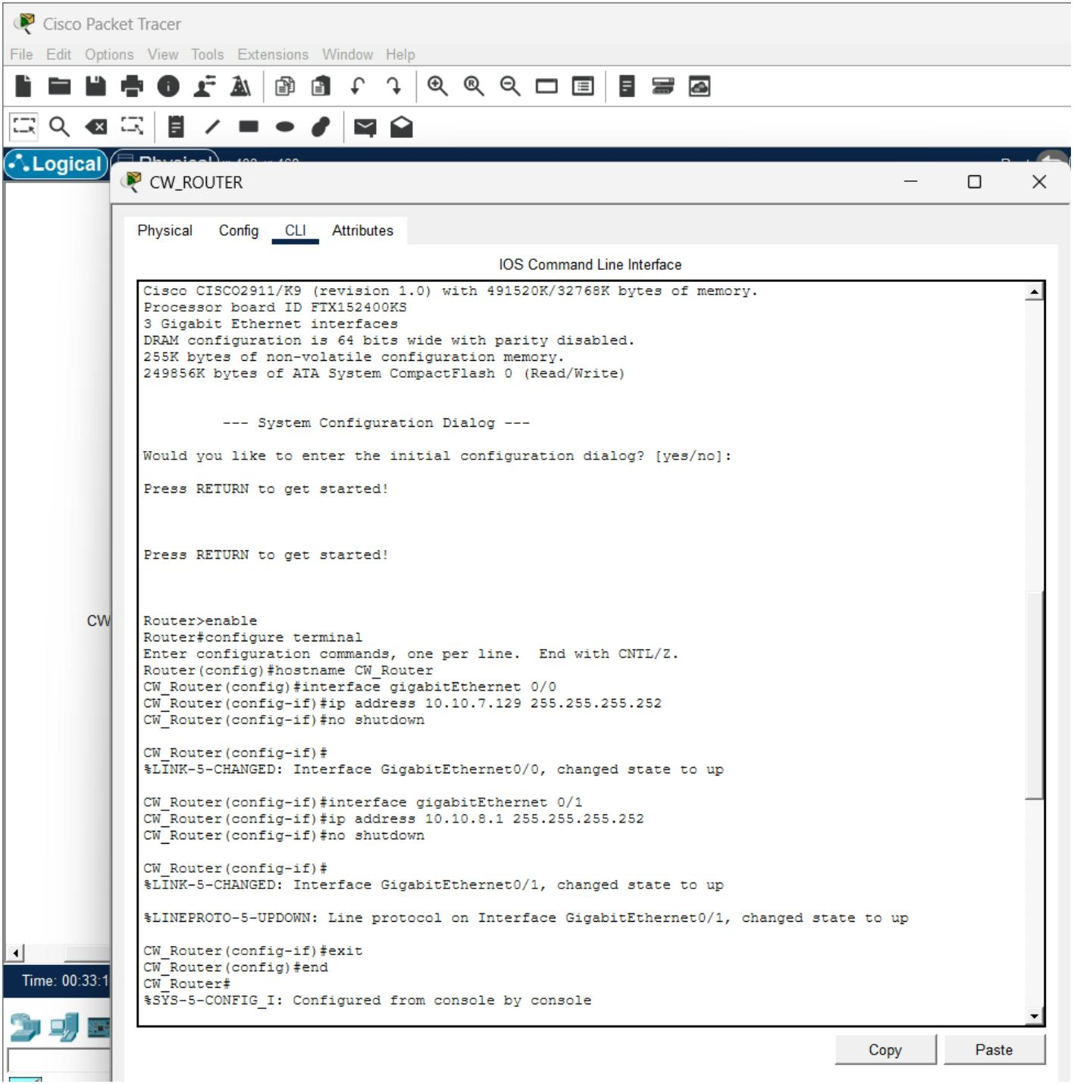

DH_Router conﬁguration and interface verﬁcation:
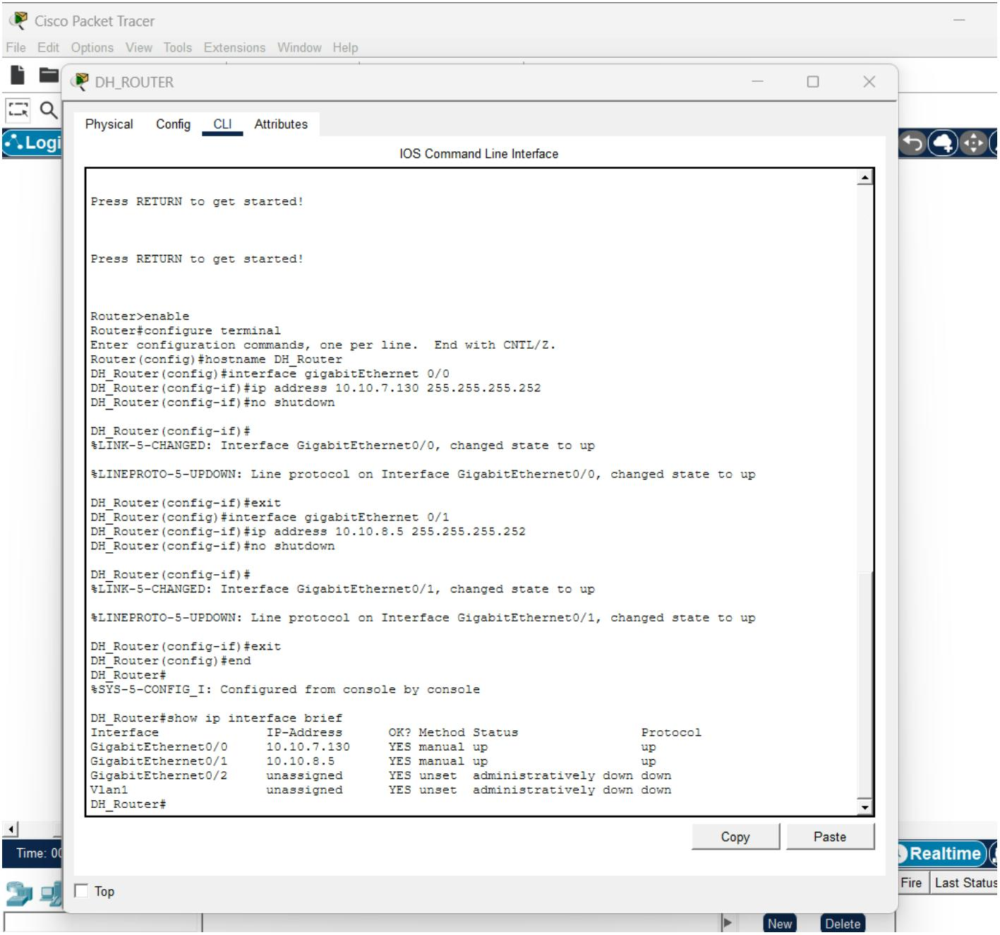

CW_DIST Layer 3 Conﬁguration and Interface Veriﬁcation:
CW_DIST VLANConﬁguration and Veriﬁcation:
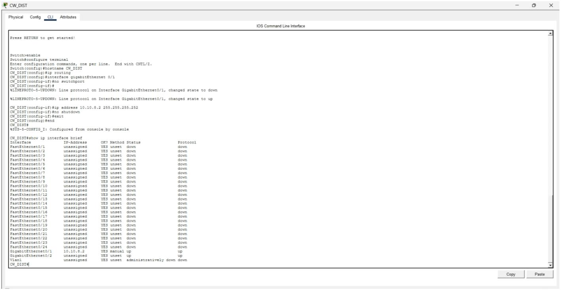
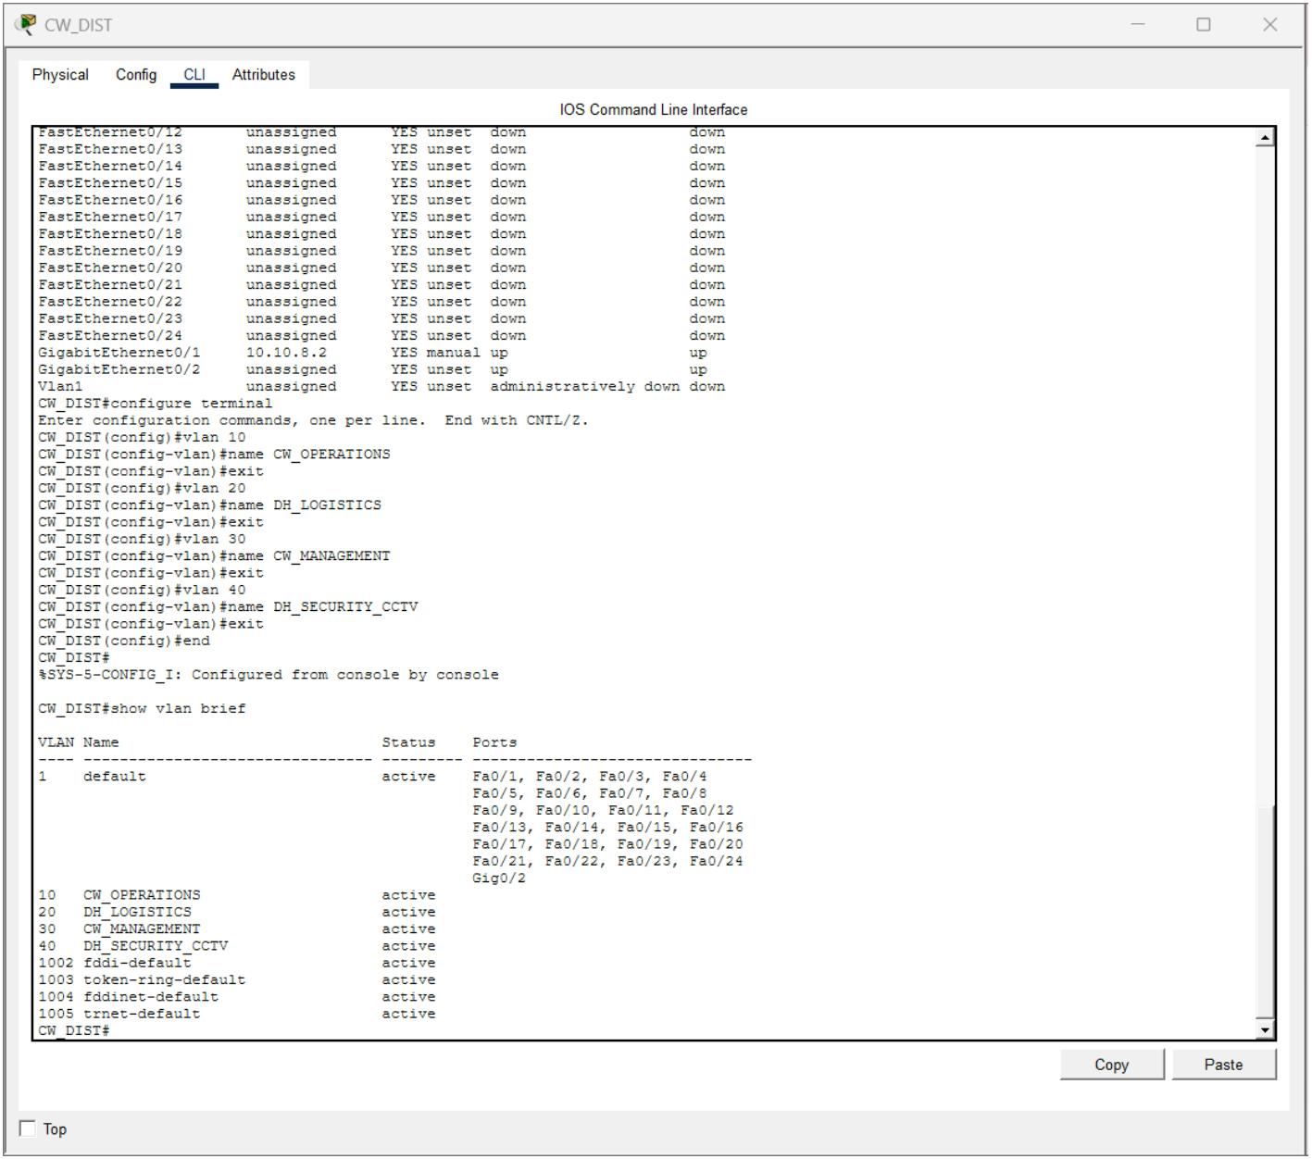

CW_DIST SVI Conﬁguration and Veriﬁcation:
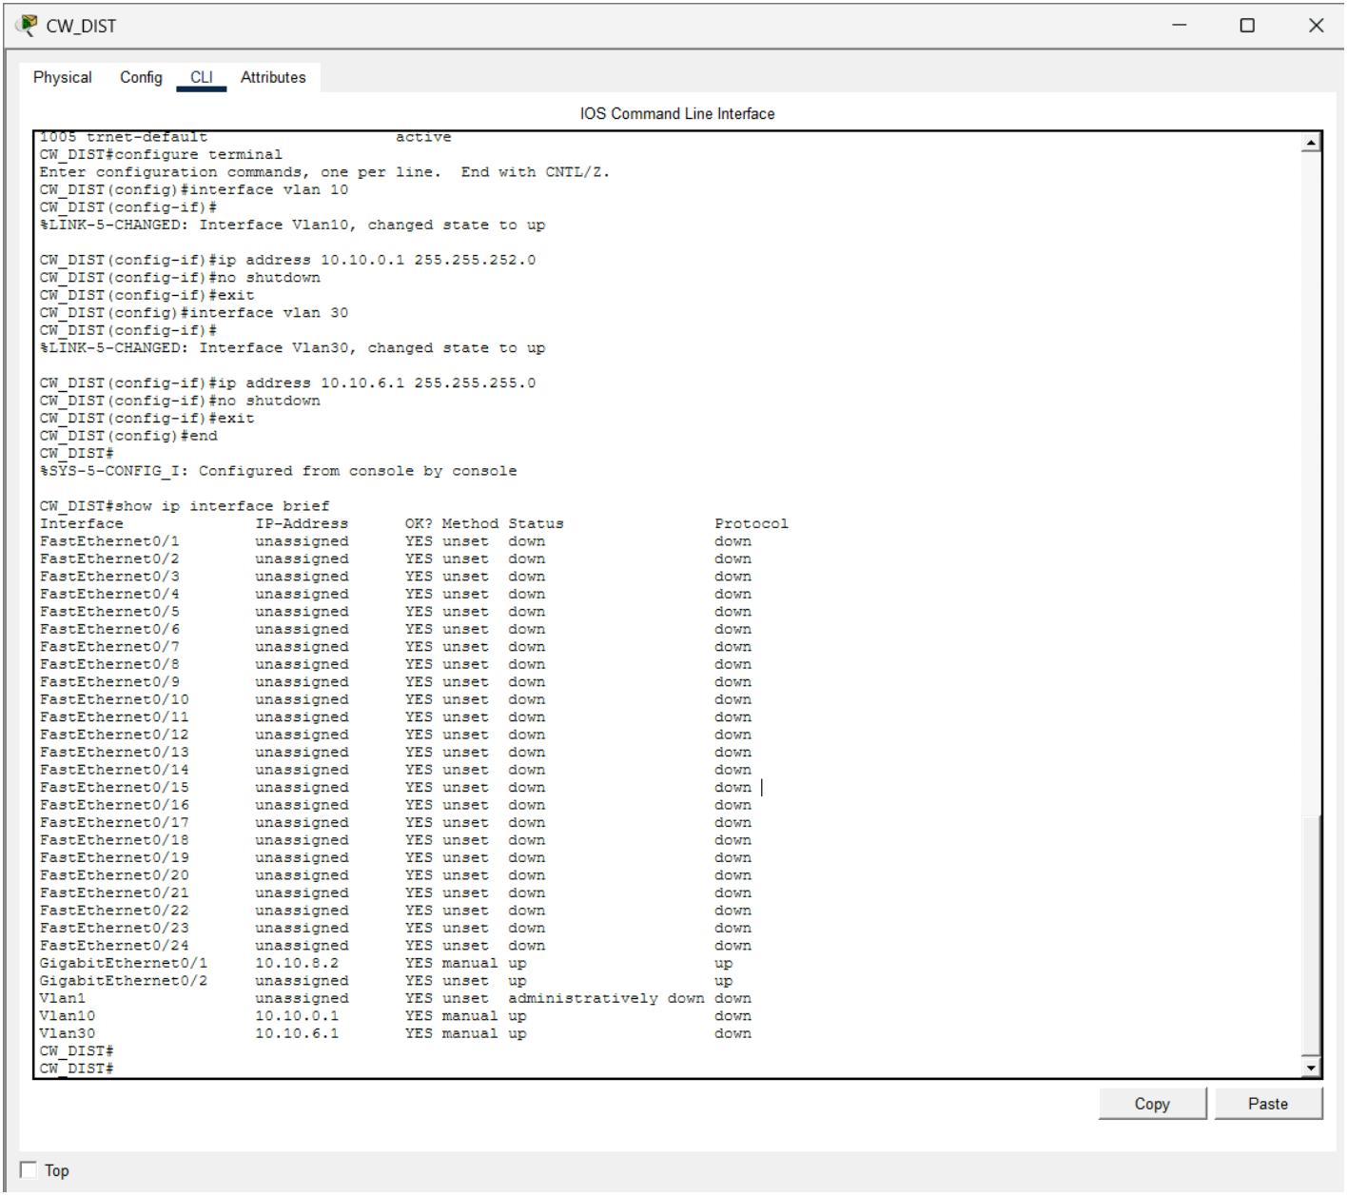

CW_DIST 802.1Q Trunk Conﬁguration and Veriﬁcation:
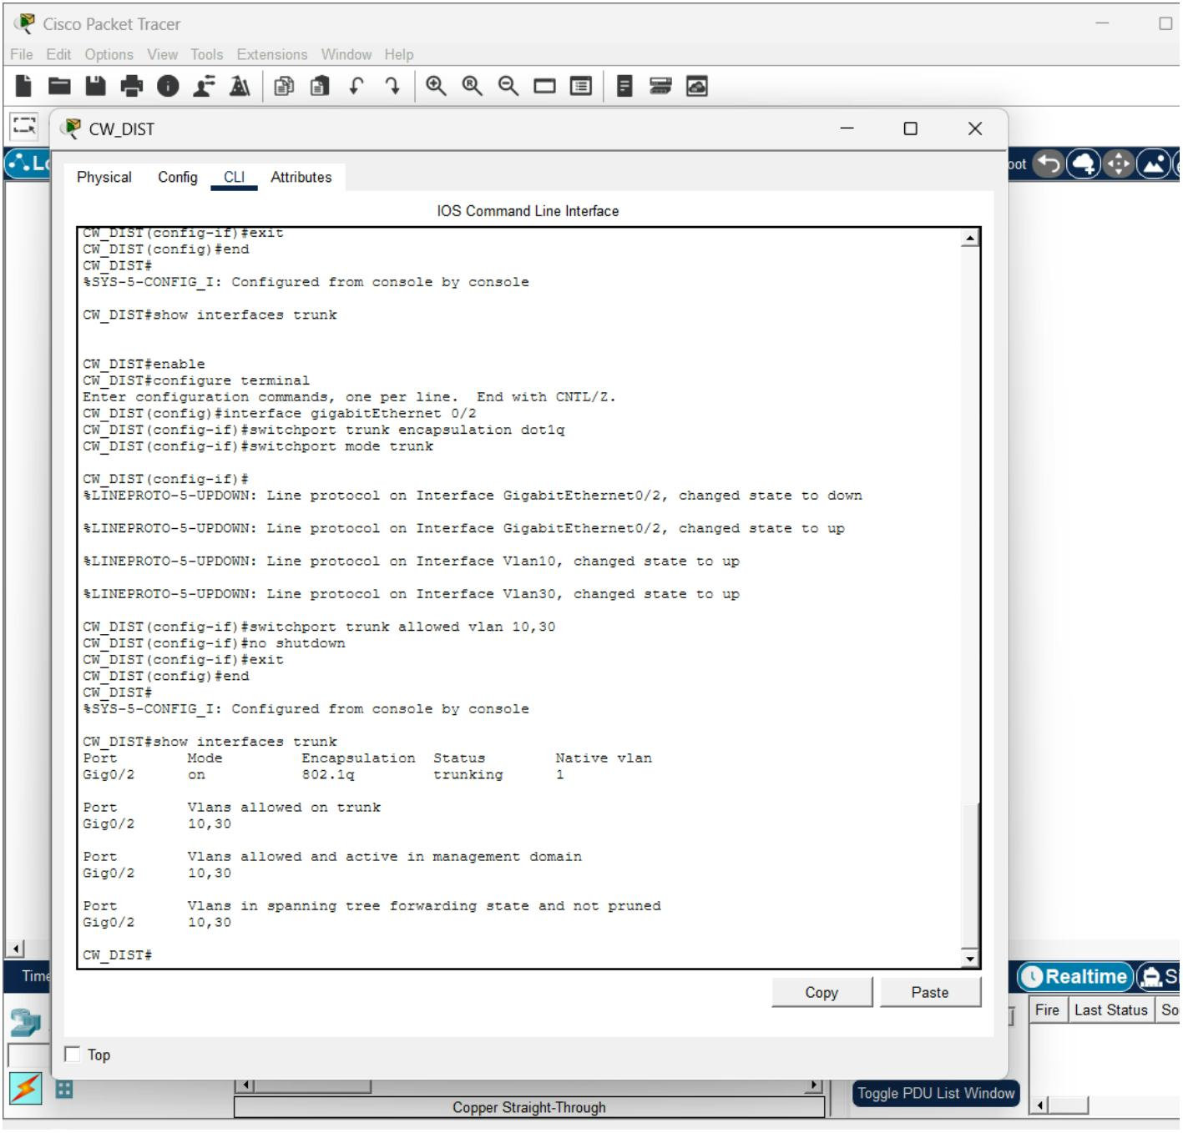
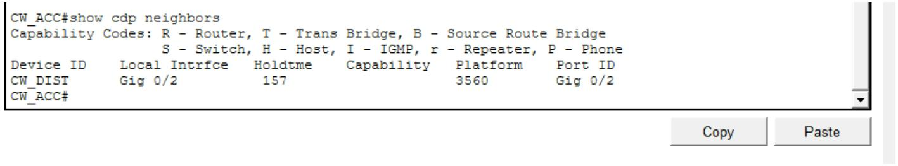

CW_ACC Access Port and Trunk Veriﬁcation:
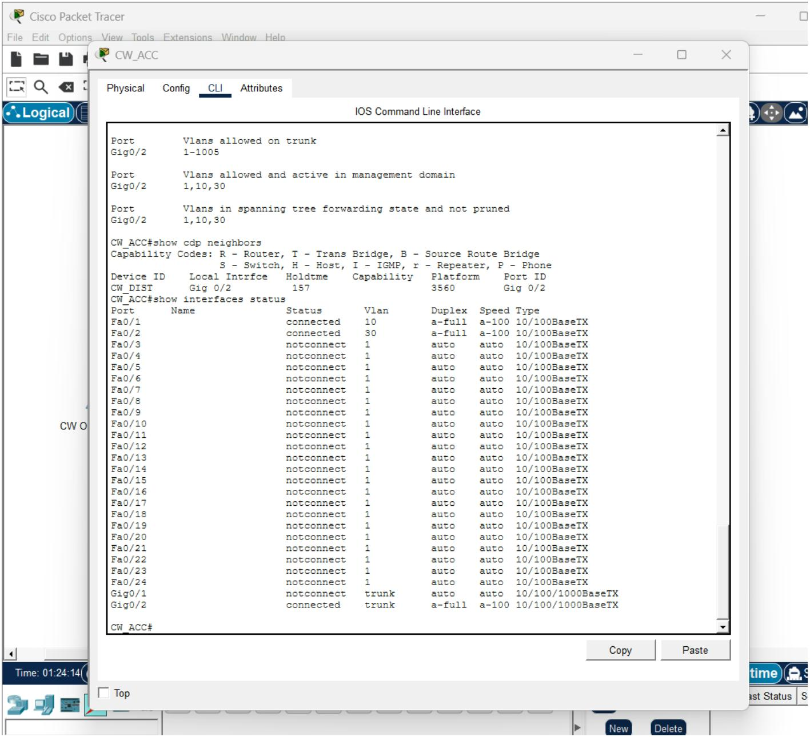

DH_DIST Layer 3 Conﬁguration and Interface Veriﬁcation:
DH_DIST VLAN SVI Conﬁguration and Interface Veriﬁcation.:
DH_ACC VLAN and Access point conﬁfuration :
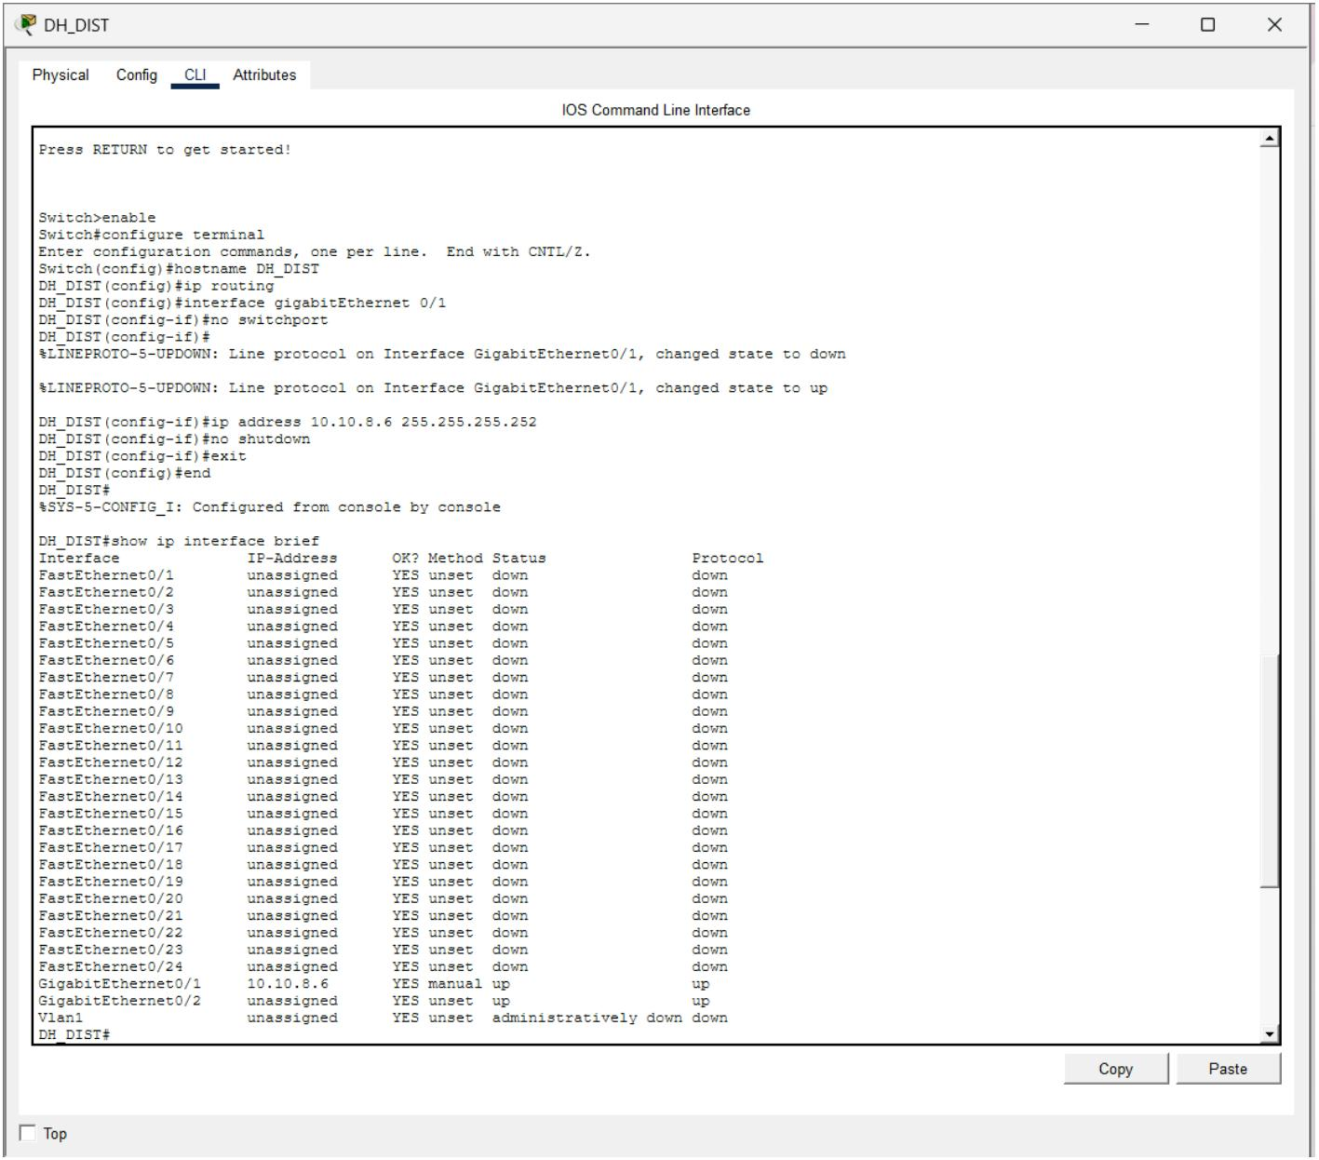
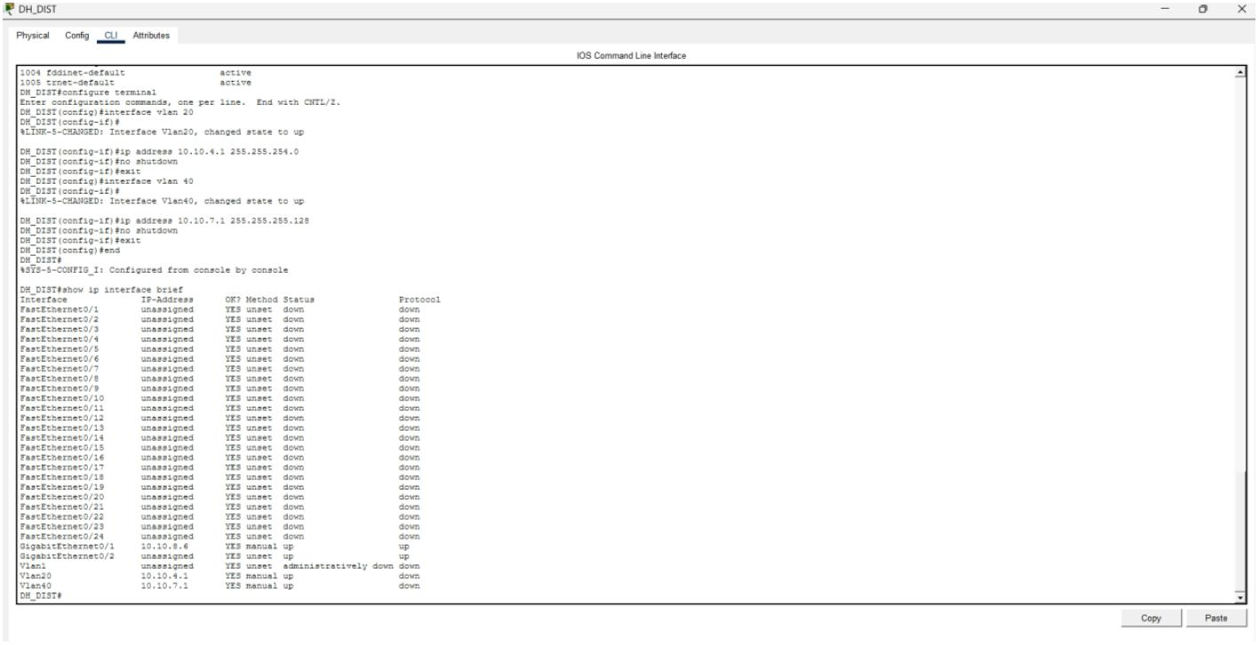

DH_ACC 802.1Q trunk conﬁguration and veriﬁcation:
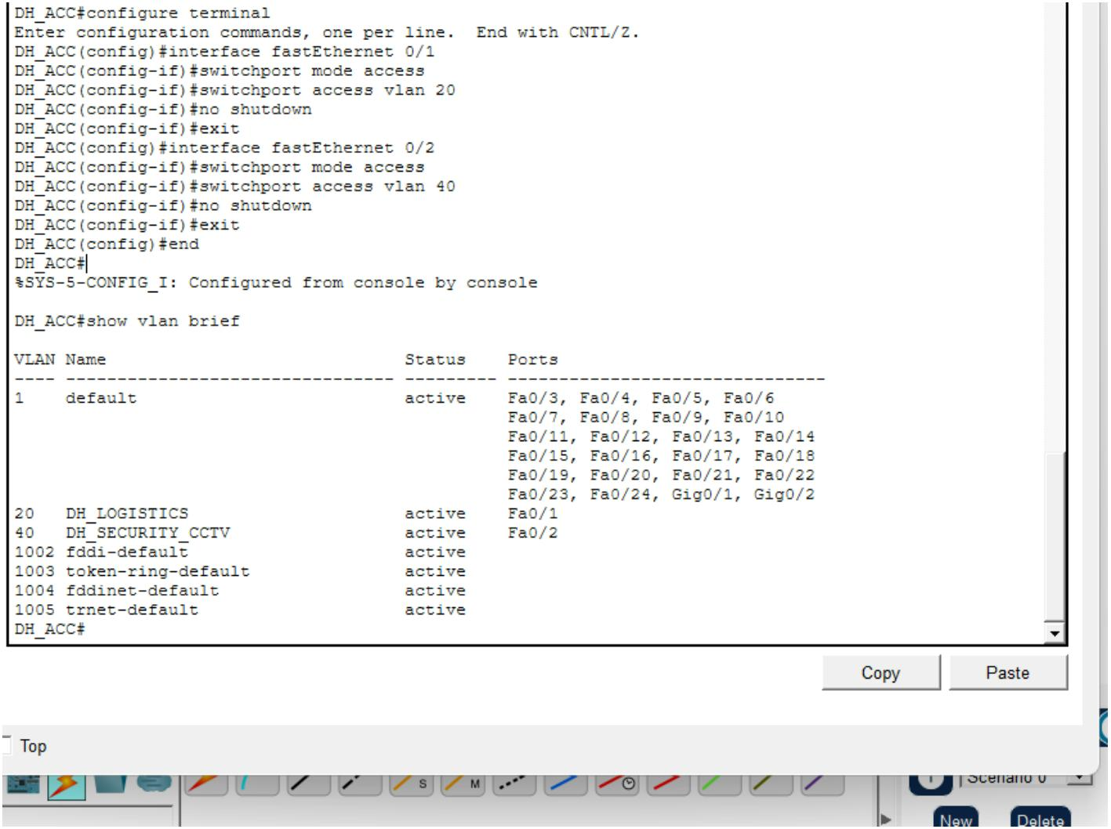
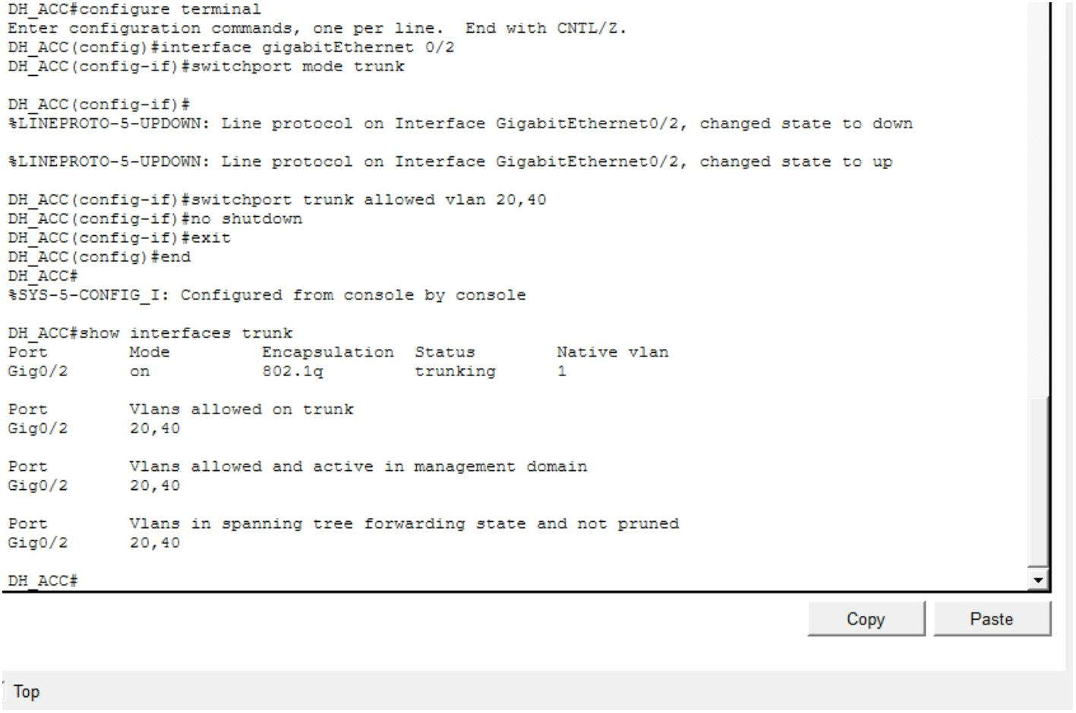

DH_DIST RSTP/STP Root Bridge Veriﬁcation for VLAN 20:
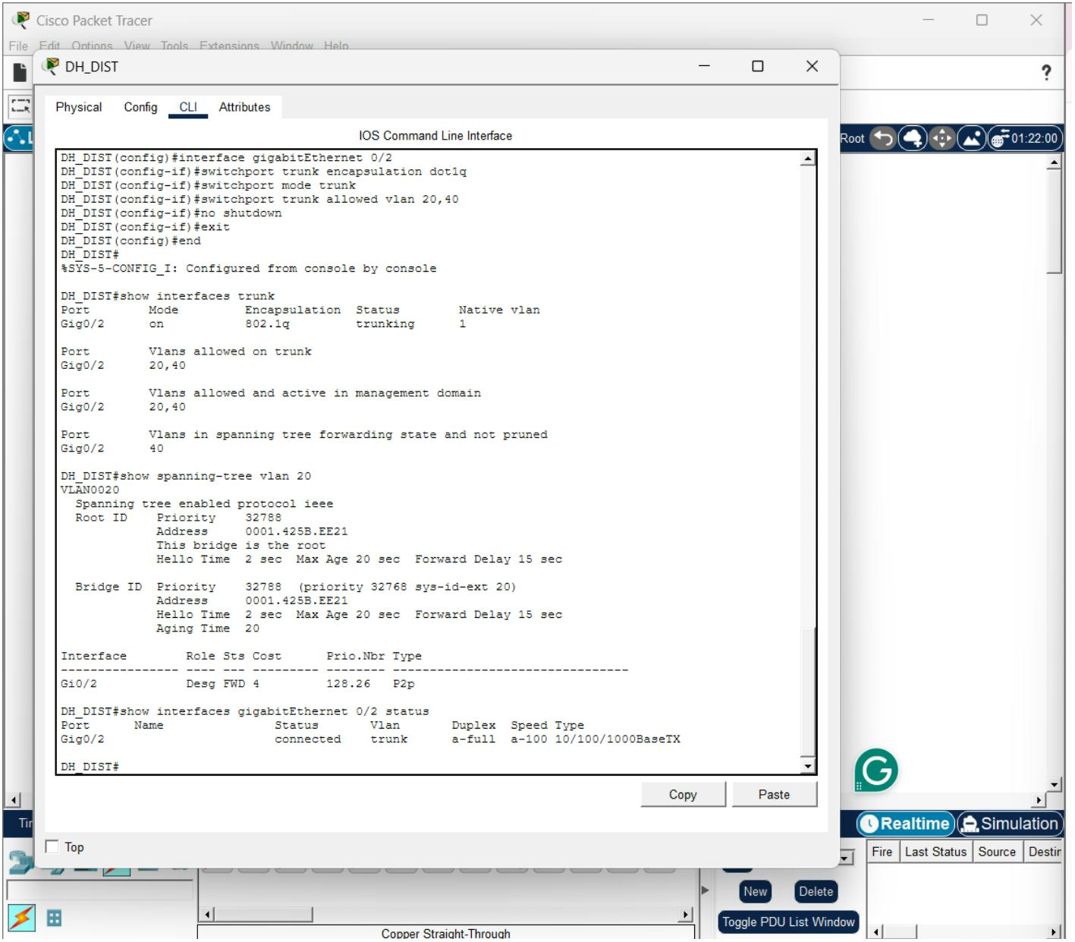

CW_Router OSPF Conﬁguration and Veriﬁcation:
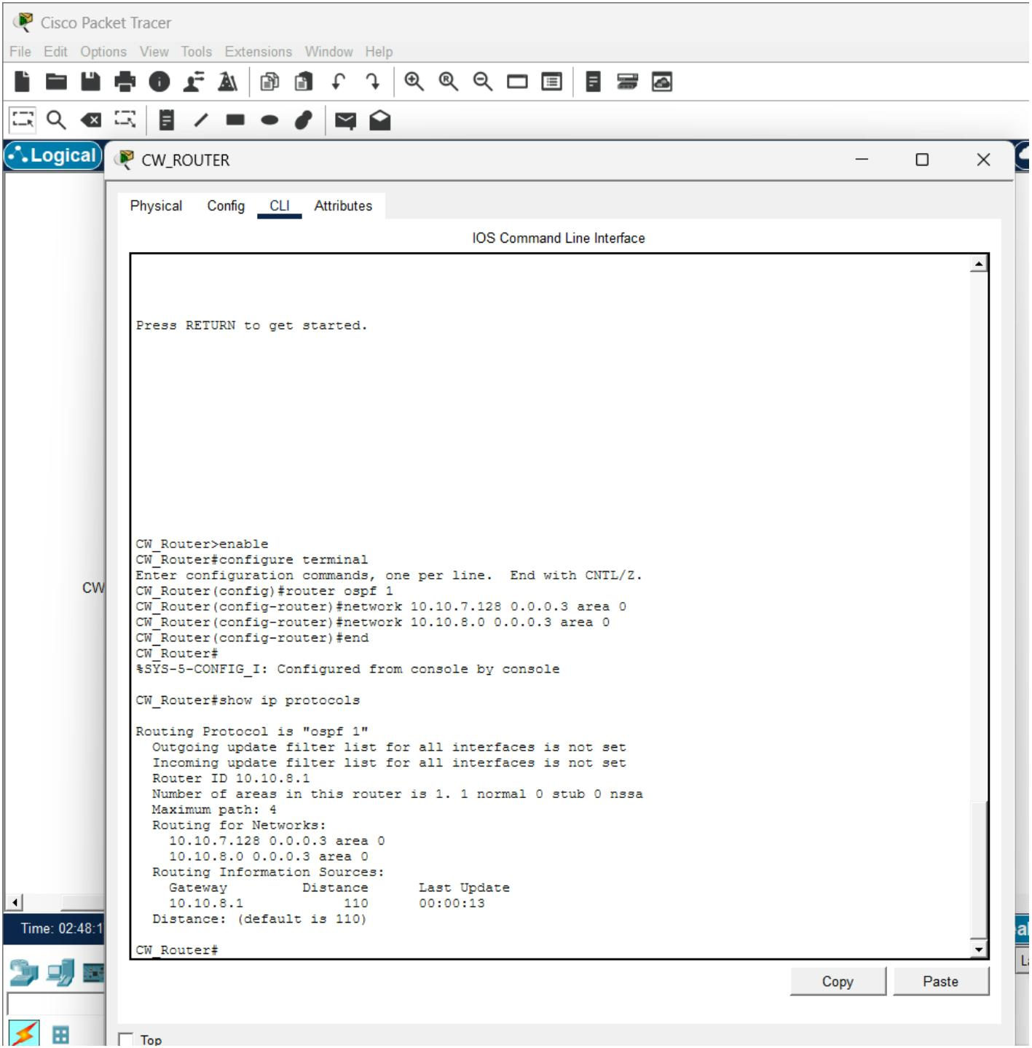

DH_Router OSPF Conﬁguration and Neighbor Adjacency Veriﬁcation:
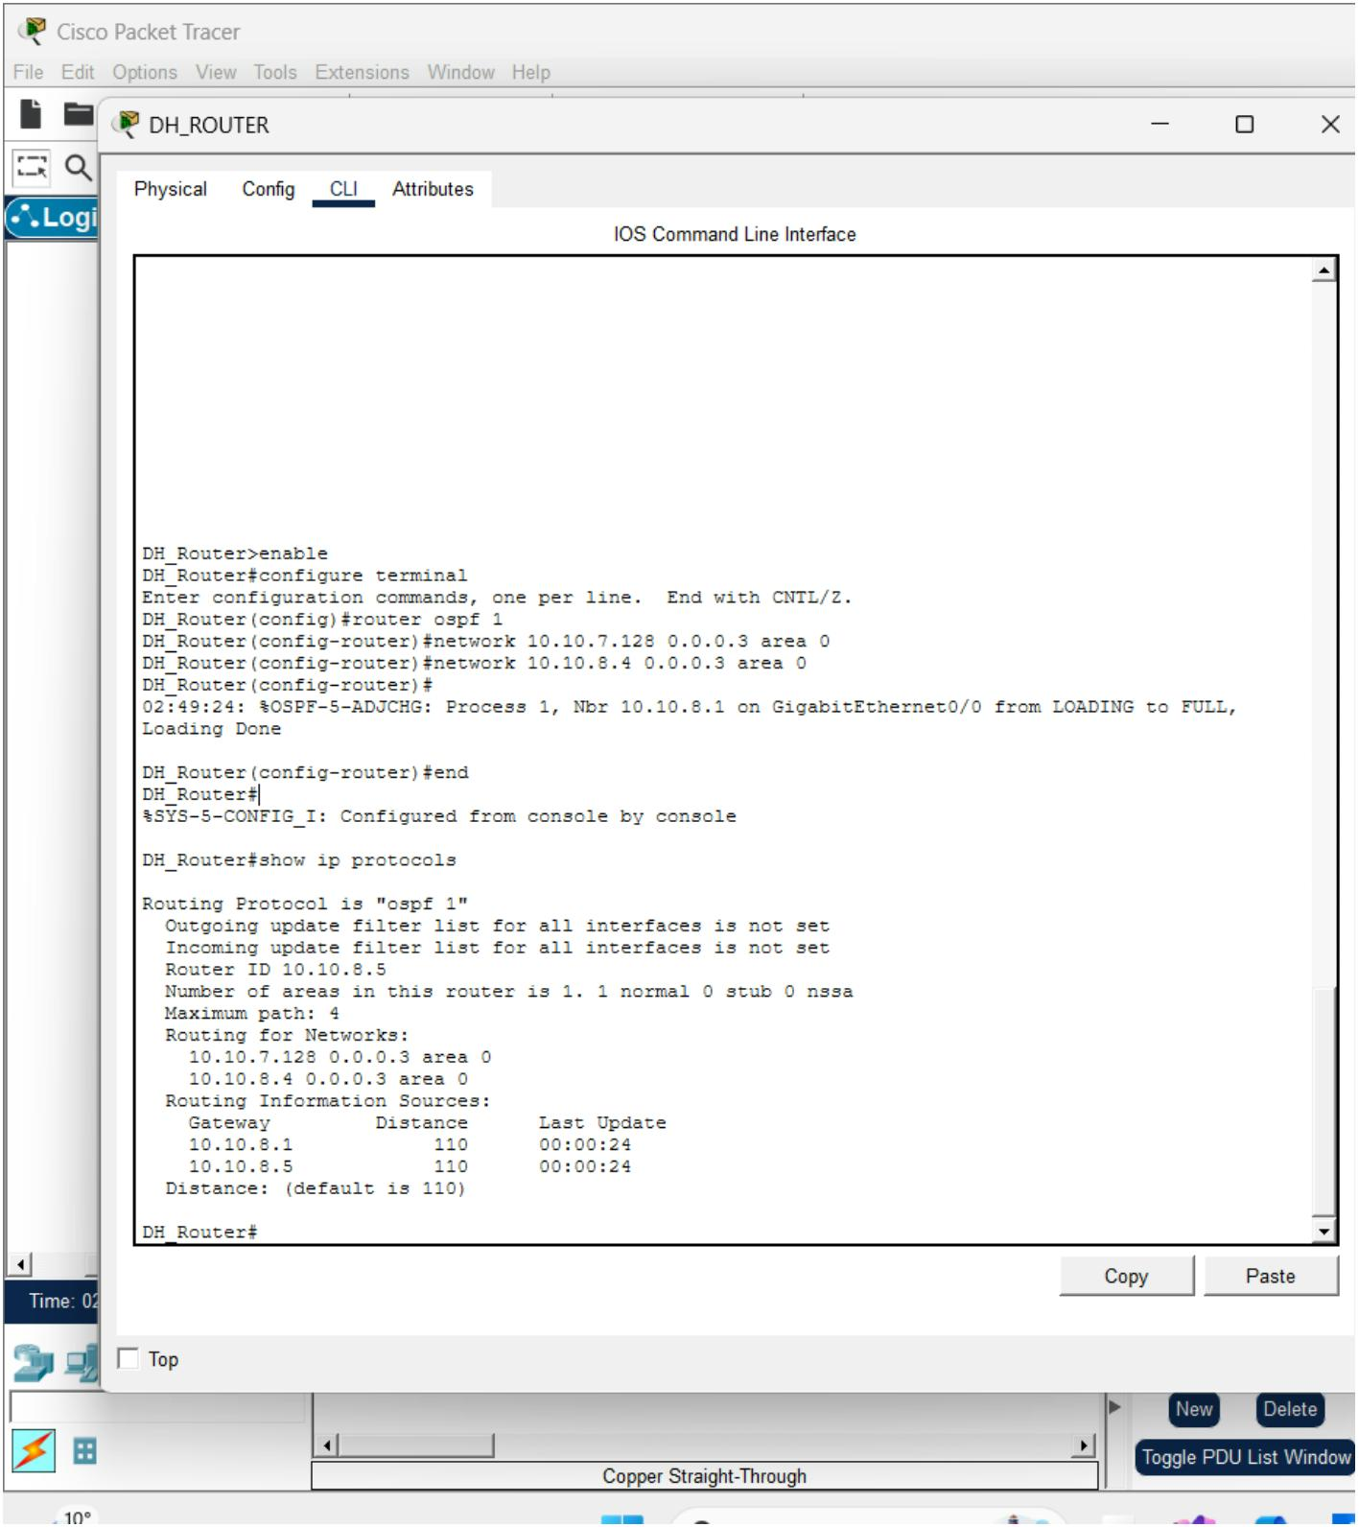

CW_DIST OSPF Conﬁguration and Neigbor veriﬁcation:
DH_DIST Conﬁguration and Neigbor Veriﬁcation
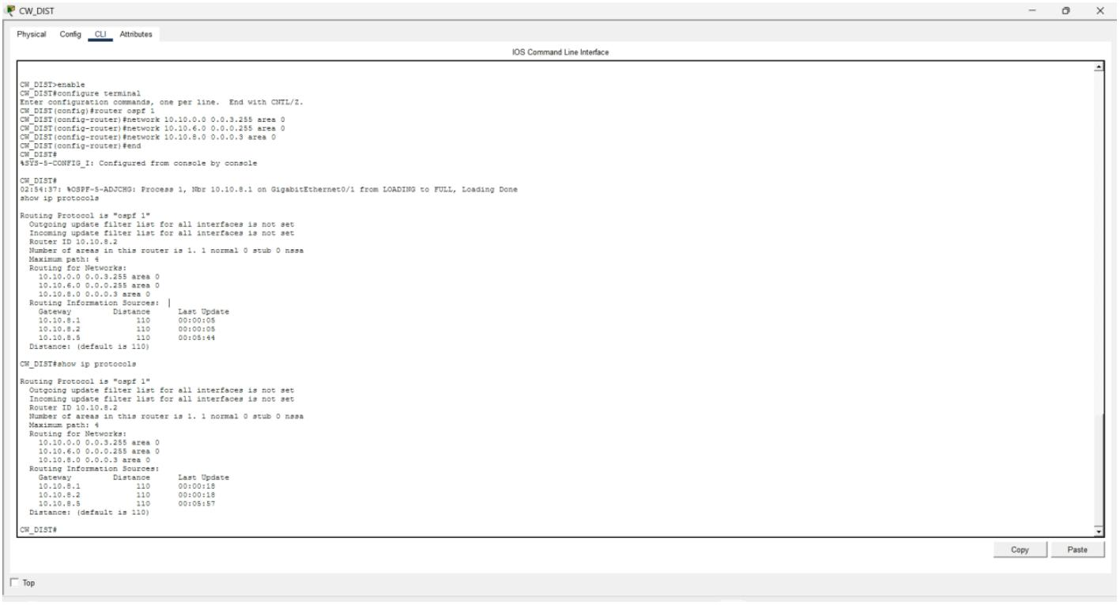

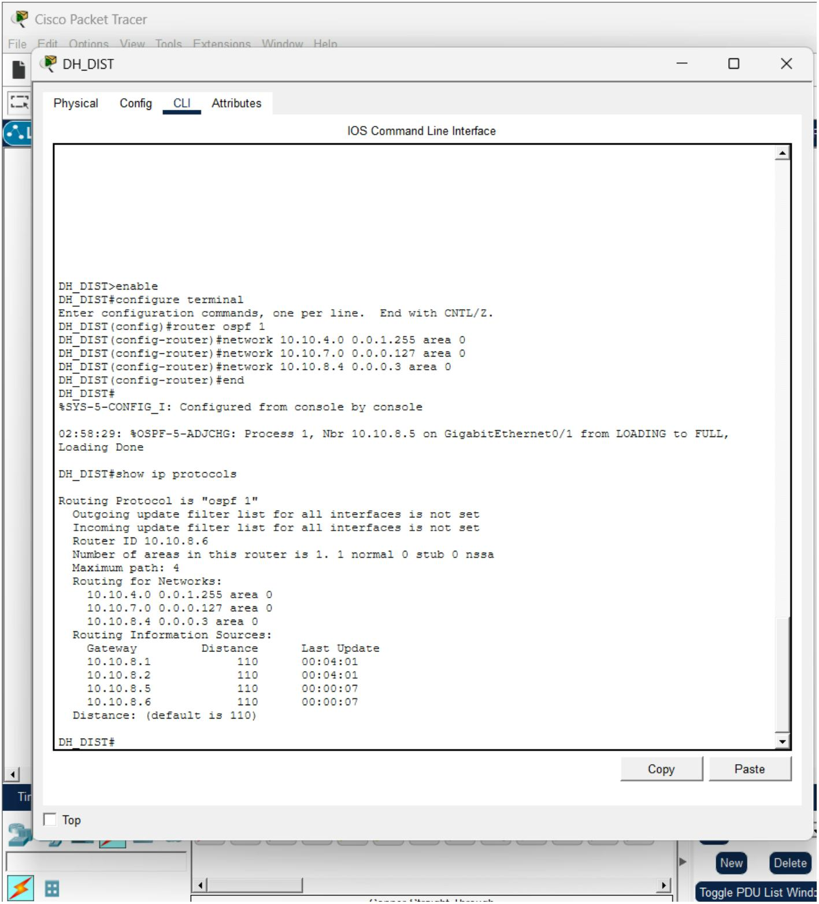

CW_Router OSPF Routing Table Veriﬁcation:
DH_router OSPF Routing Table Veriﬁcation:
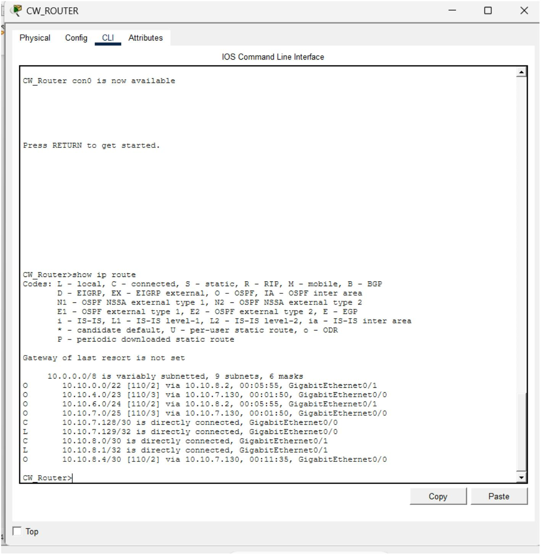

DH_DIST RSTP Root bridge veriﬁcation :
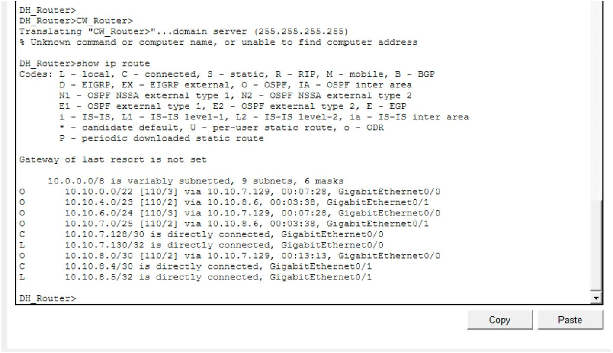
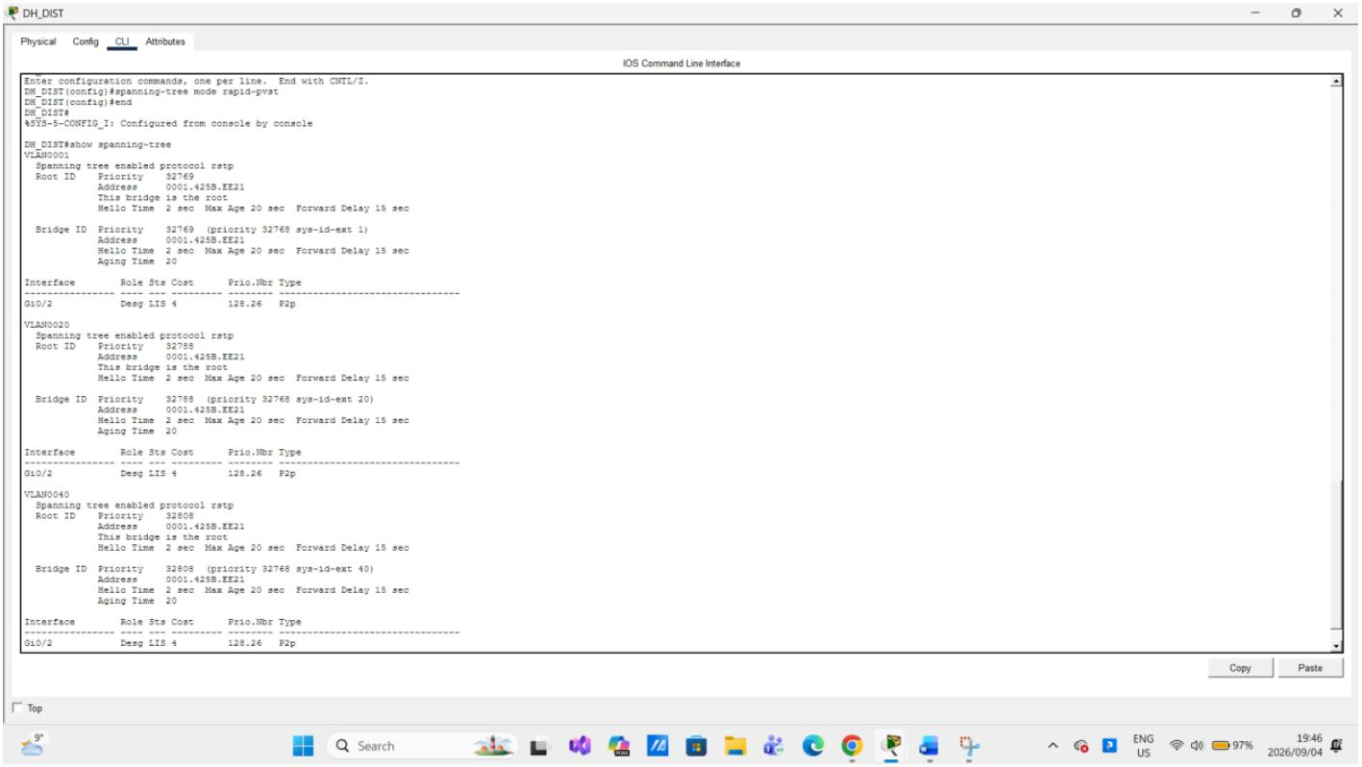

CW_ACC 802.1Q Trunk Veriﬁcation:
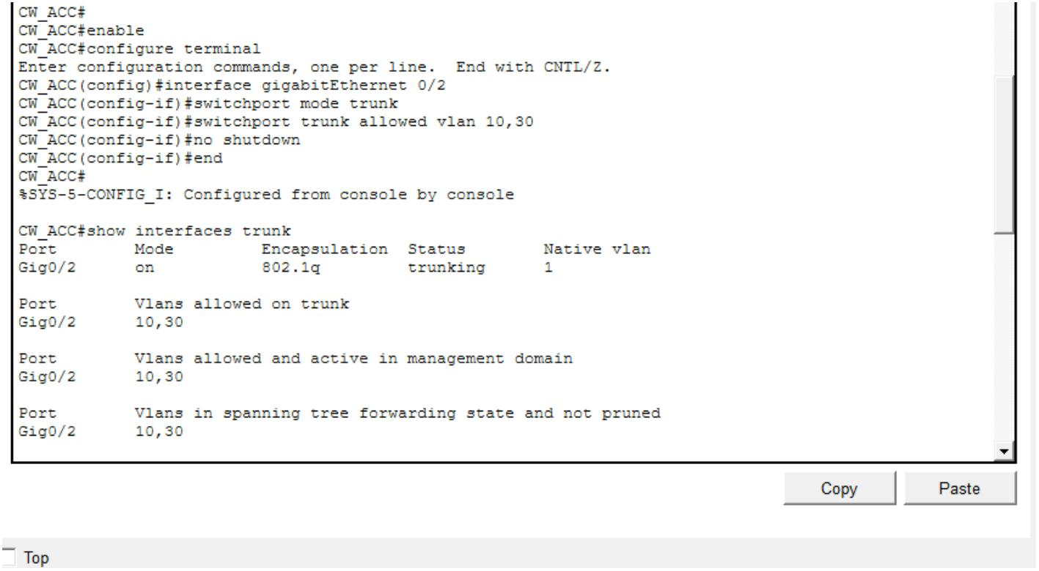

CW_ACC RSTP Veriﬁcation for Vlan 30:
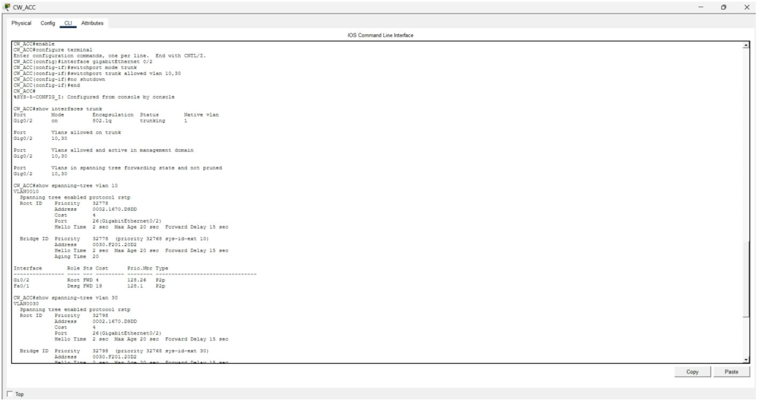
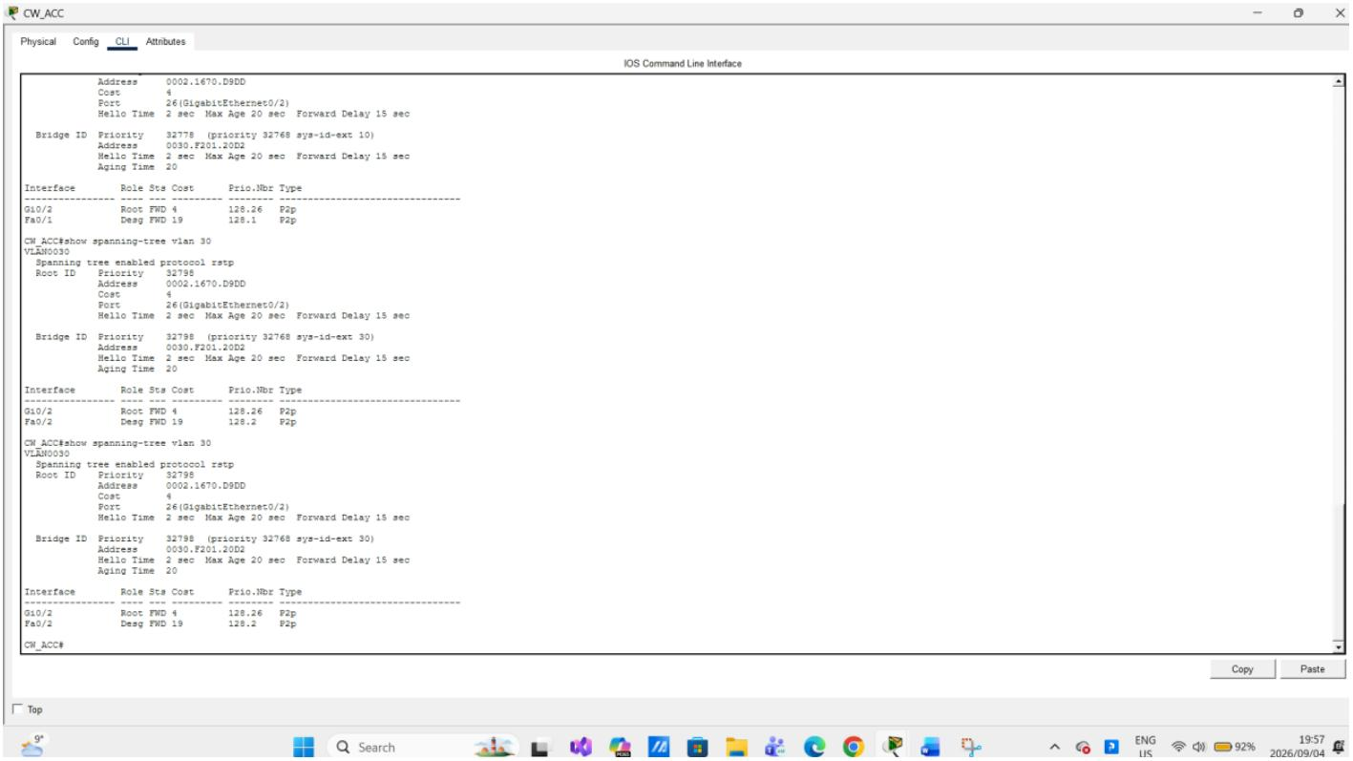

DH_ACC RSTP Veriﬁcation:
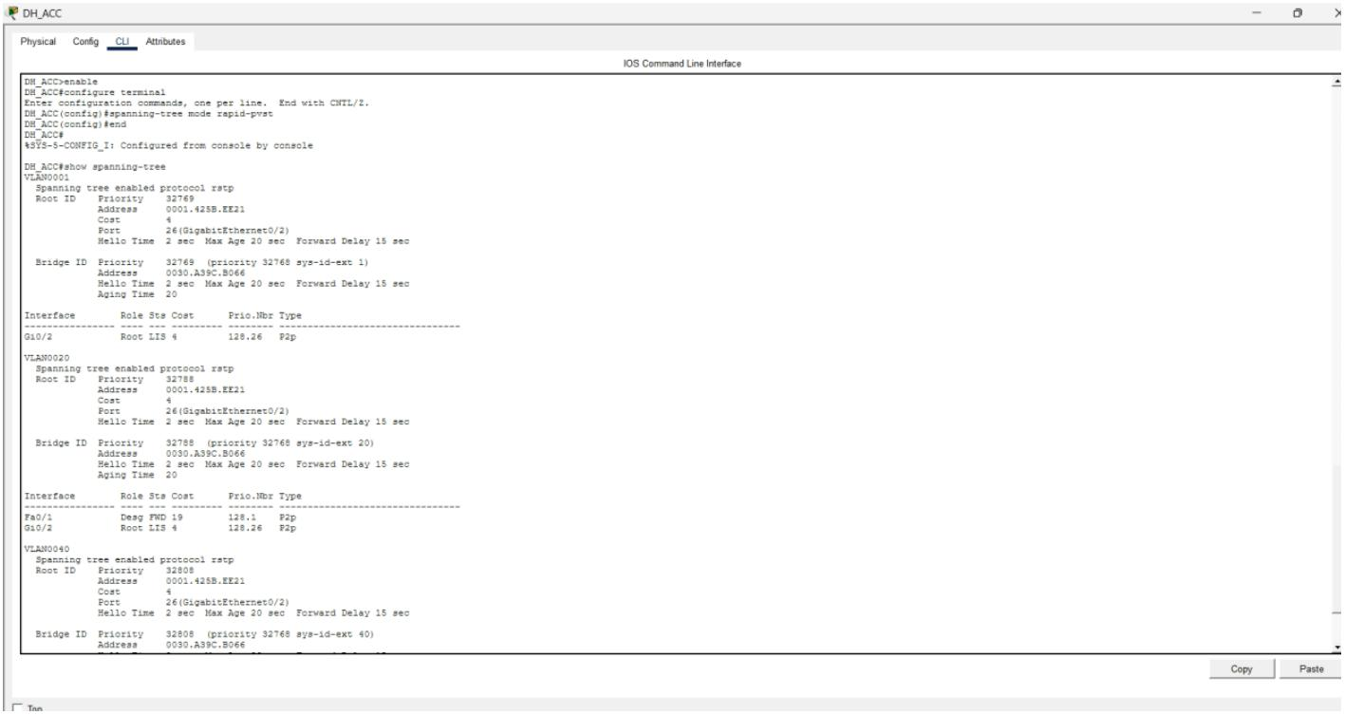
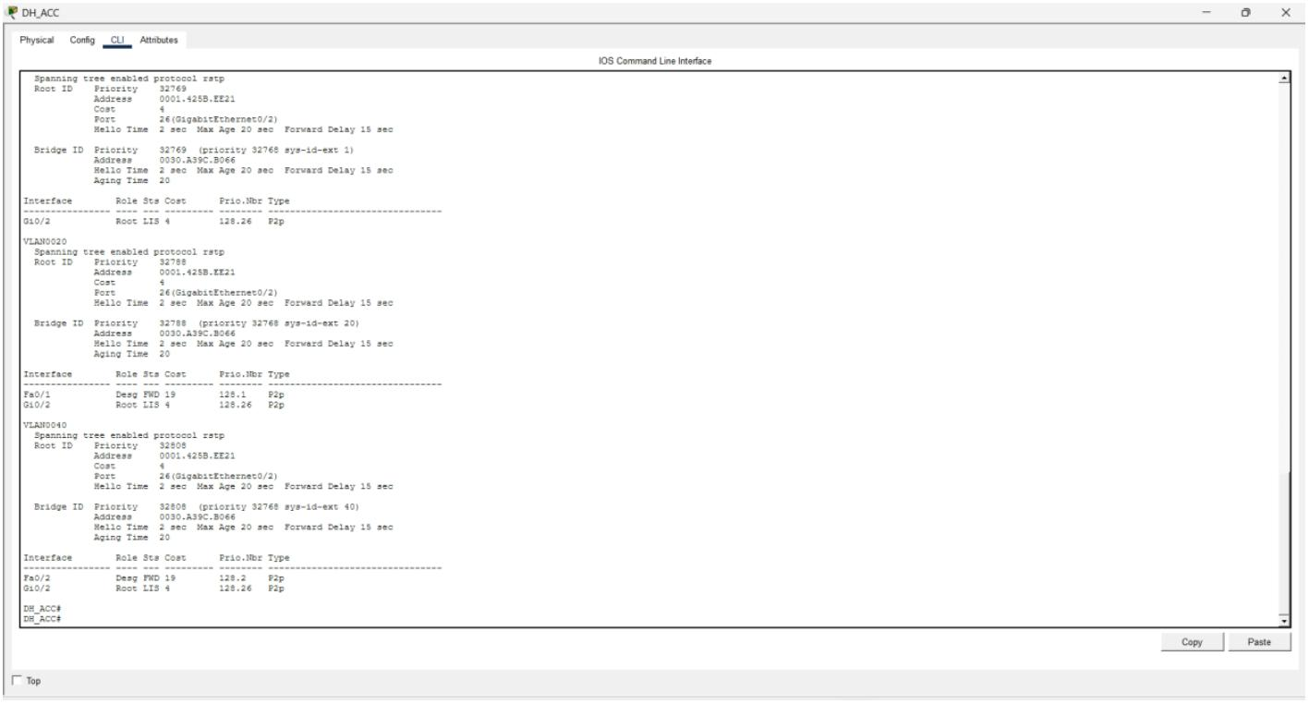

Inter-site and inter-VLAN Connectivity Veriﬁcation:
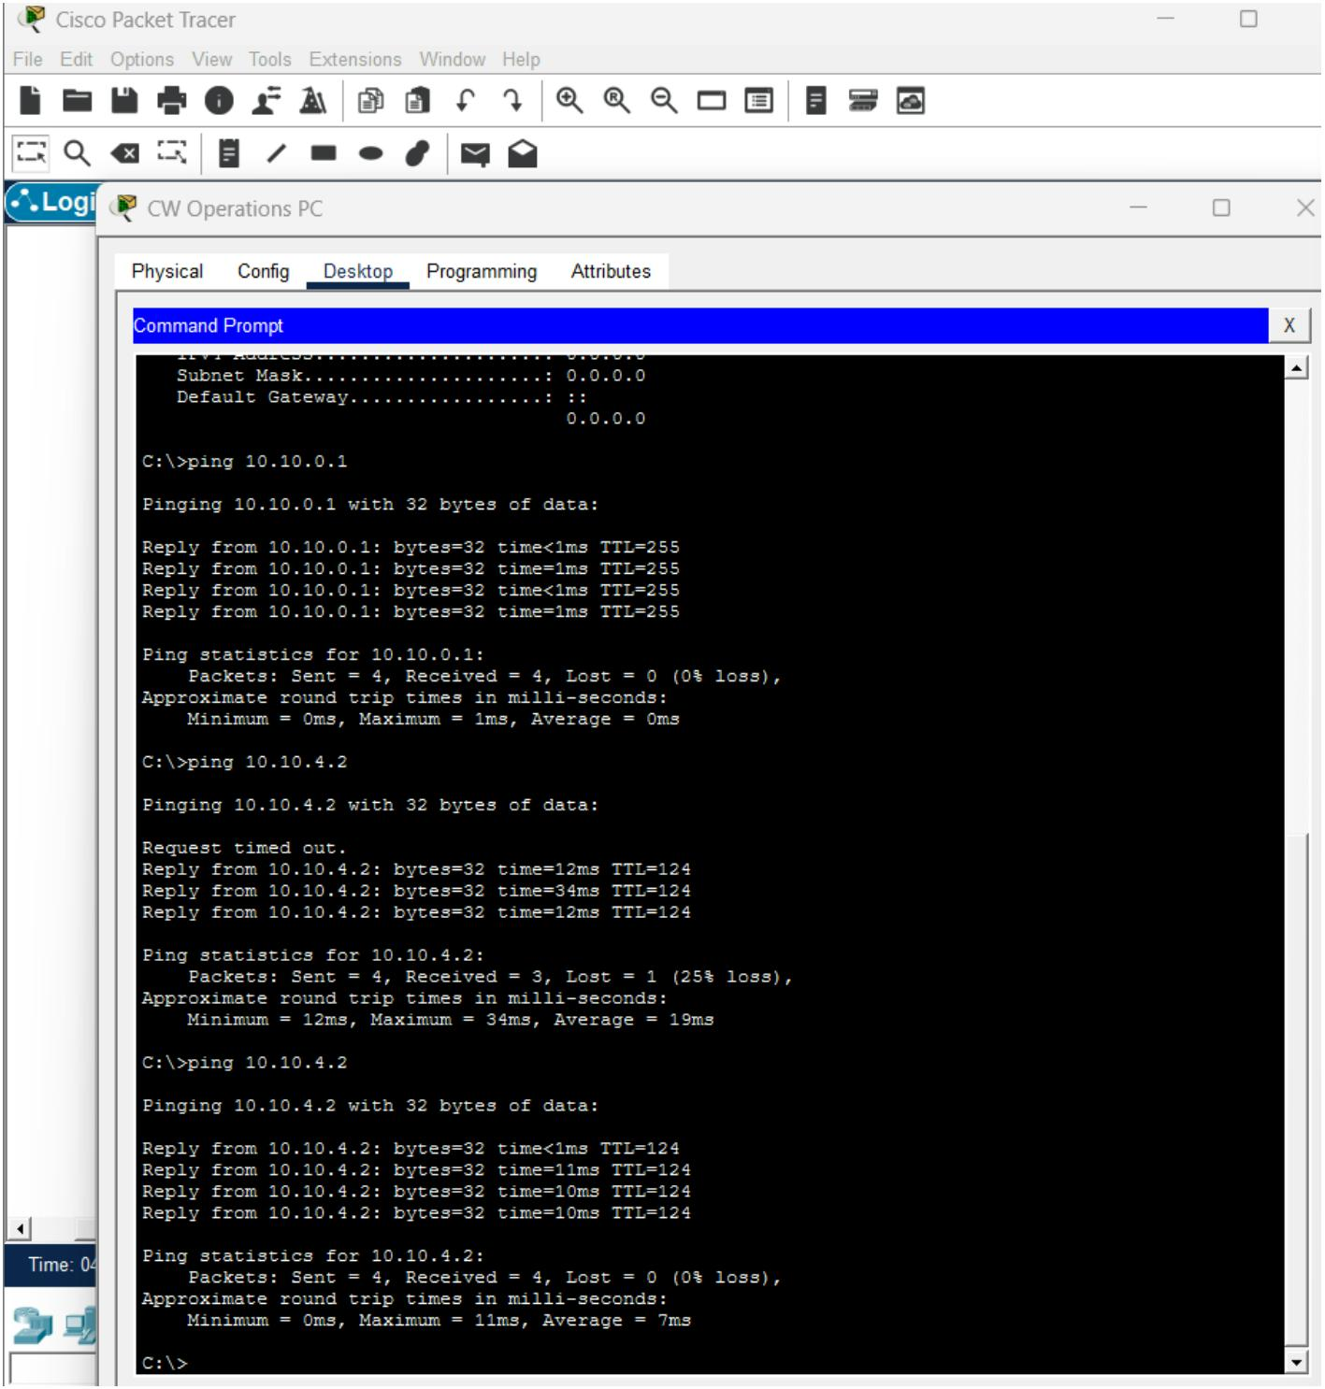

Reverse inter-site connectivity Veriﬁcation:
Question 3
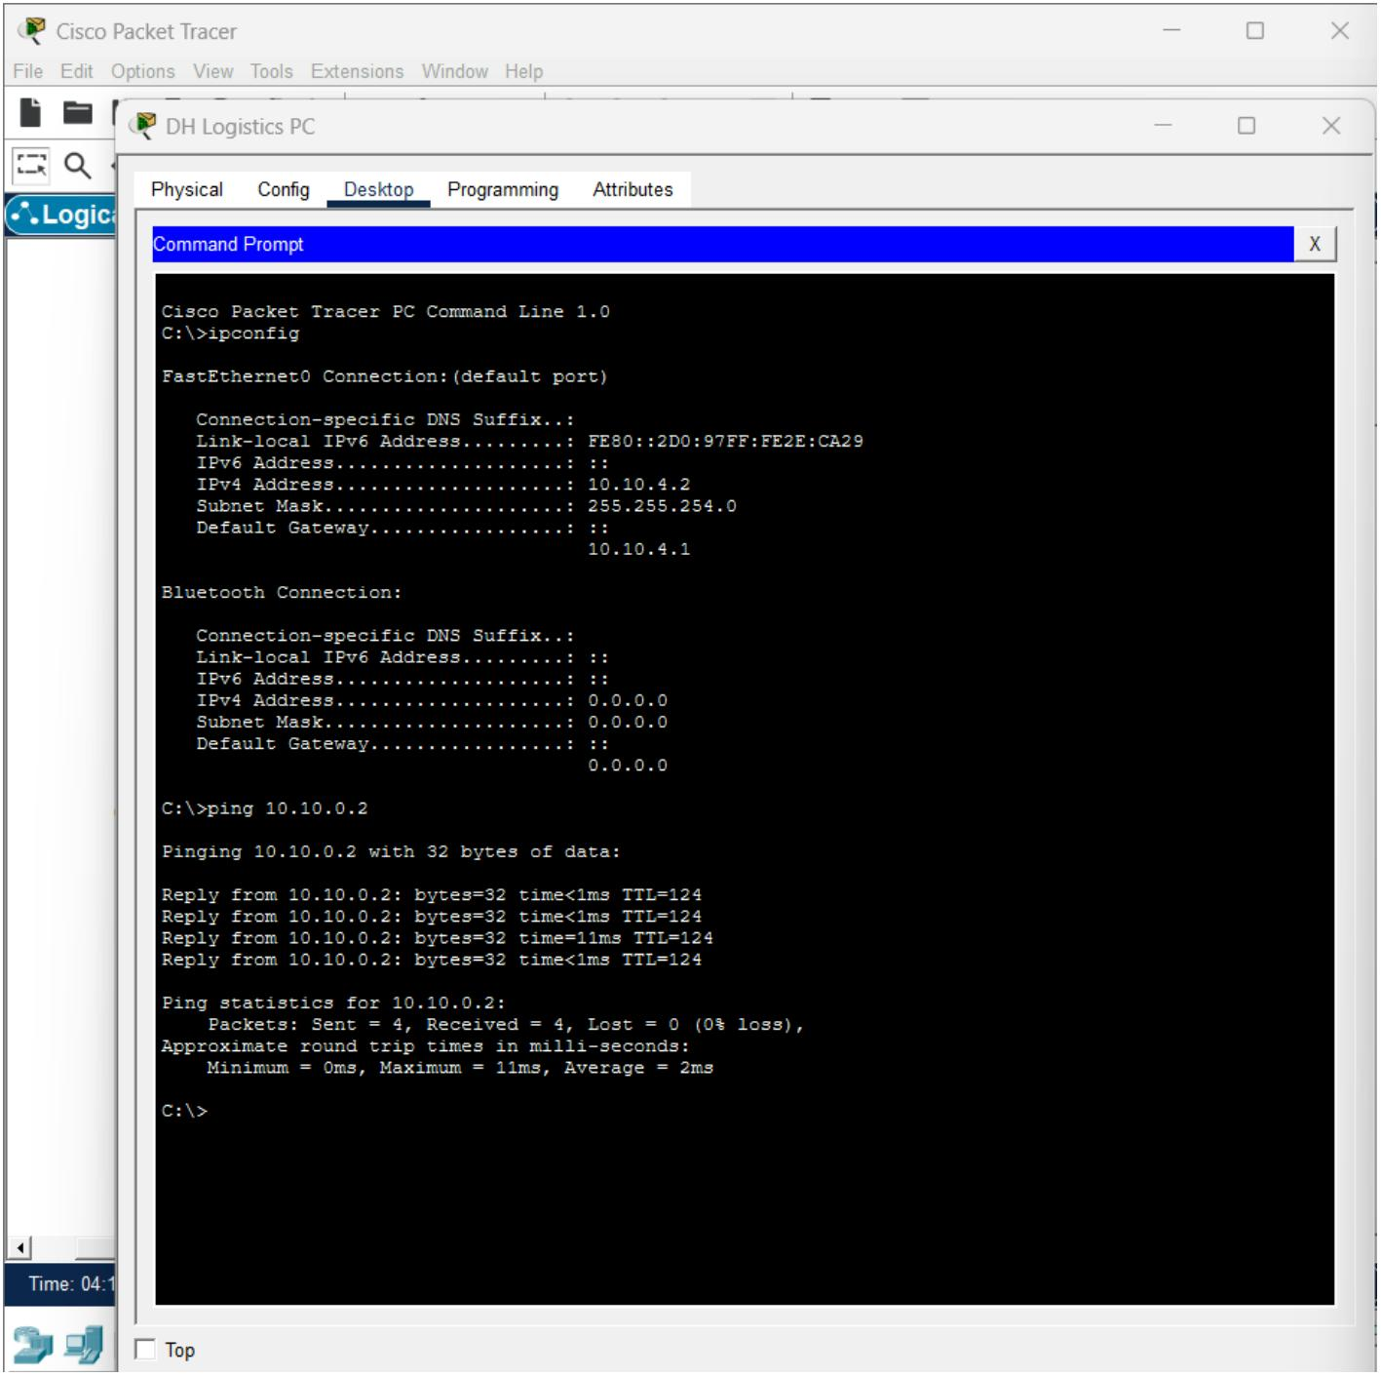

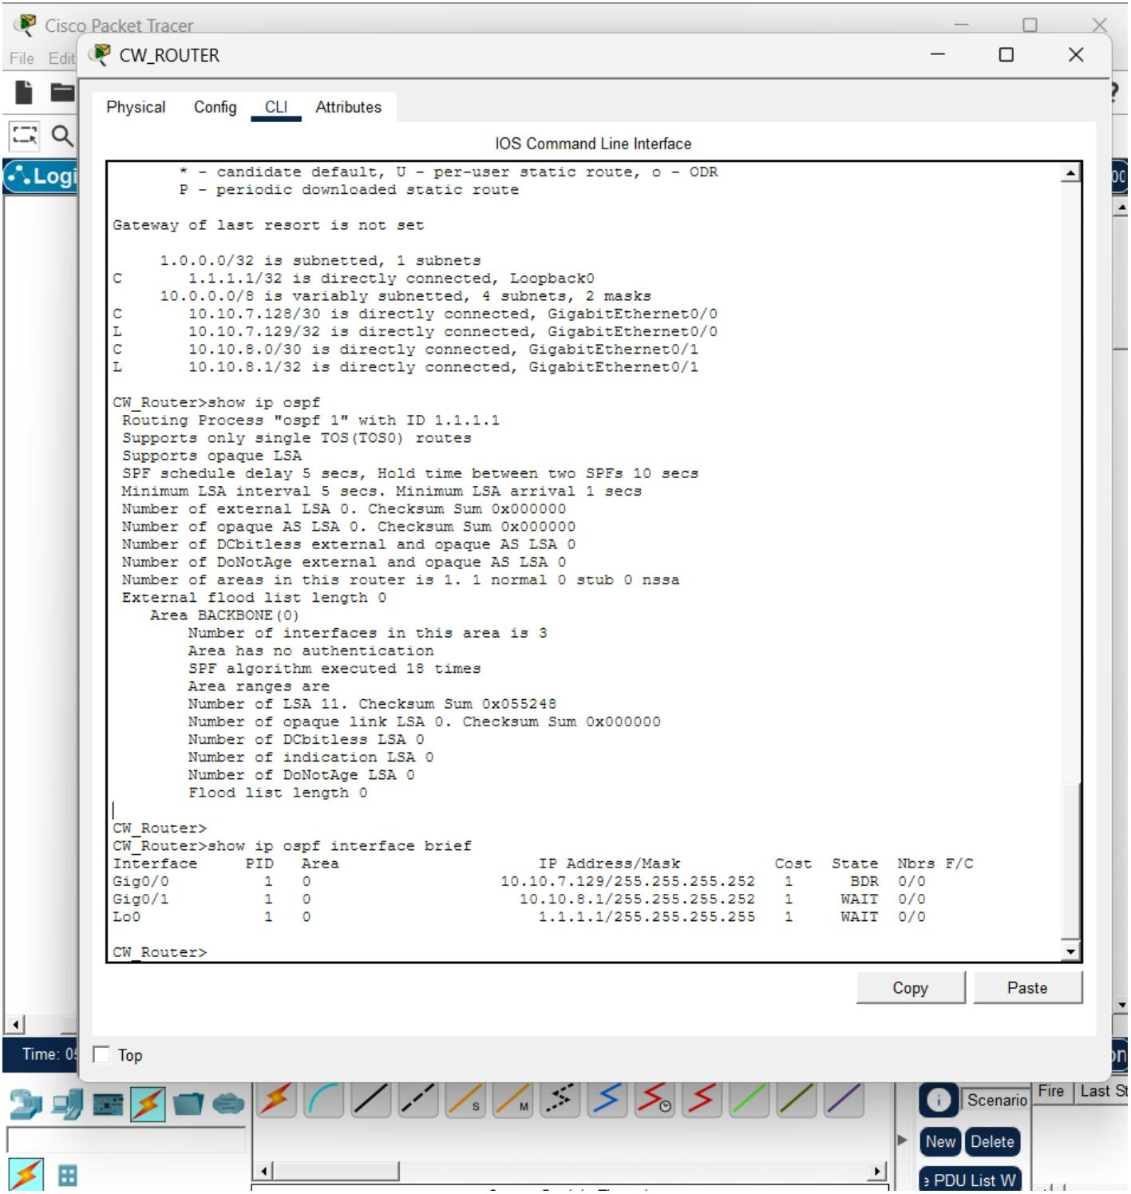

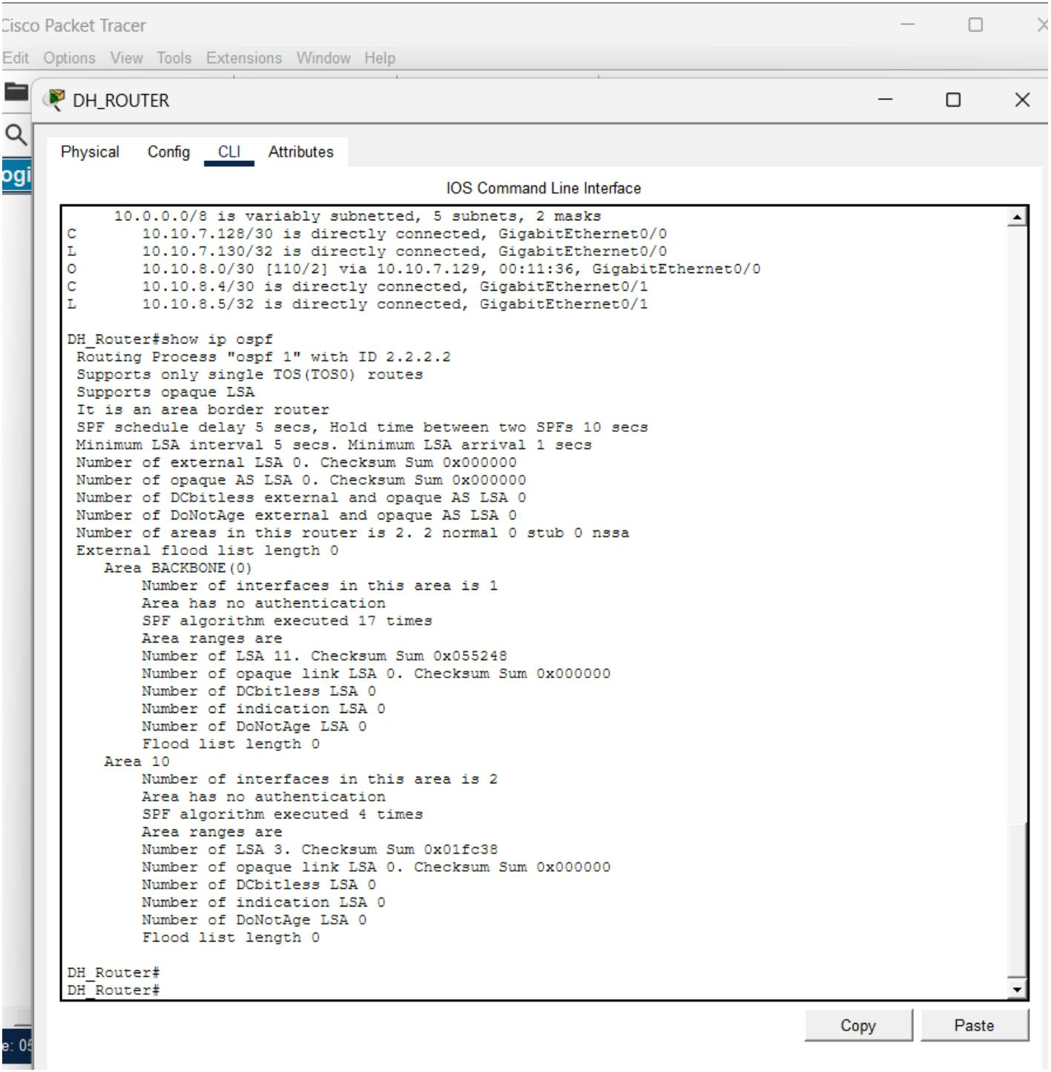
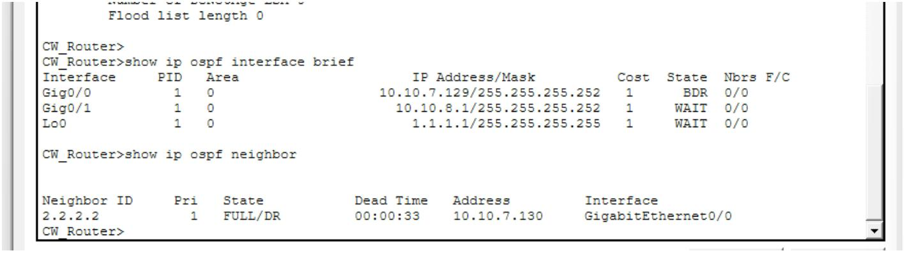
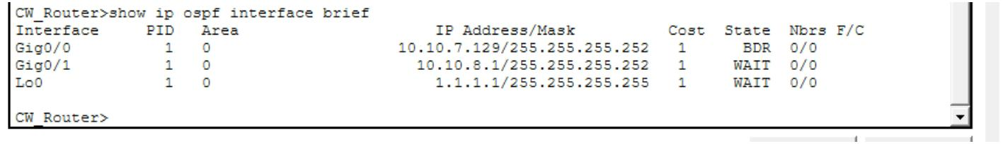

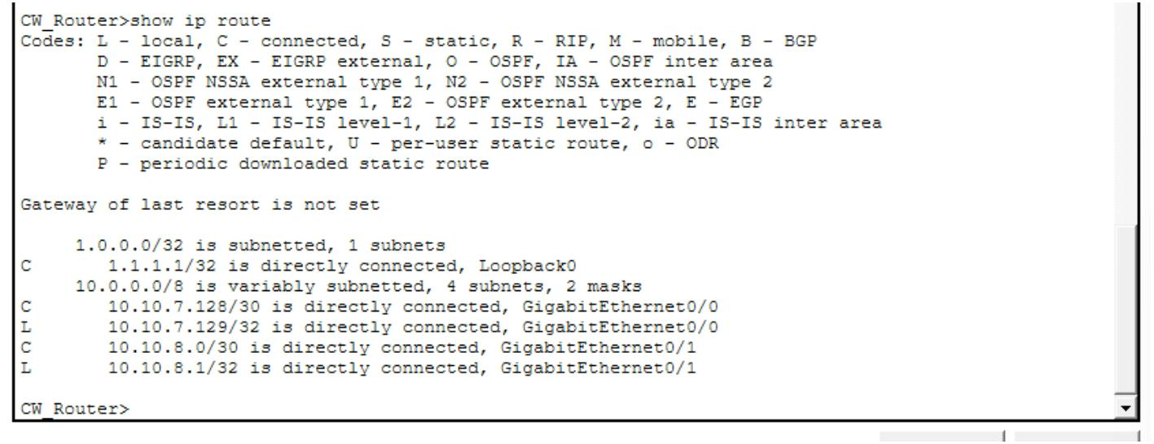
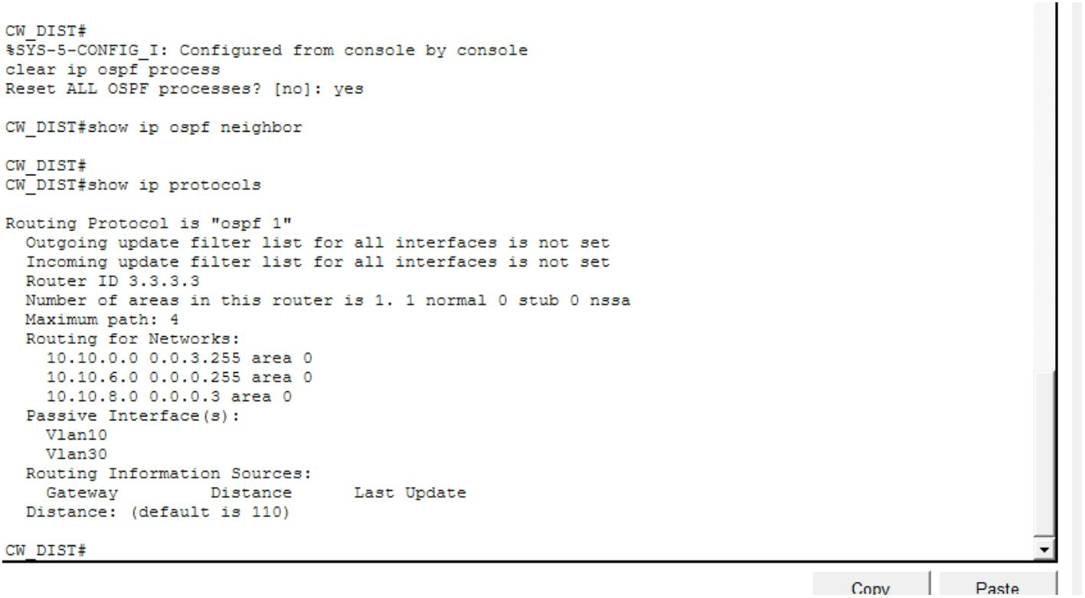
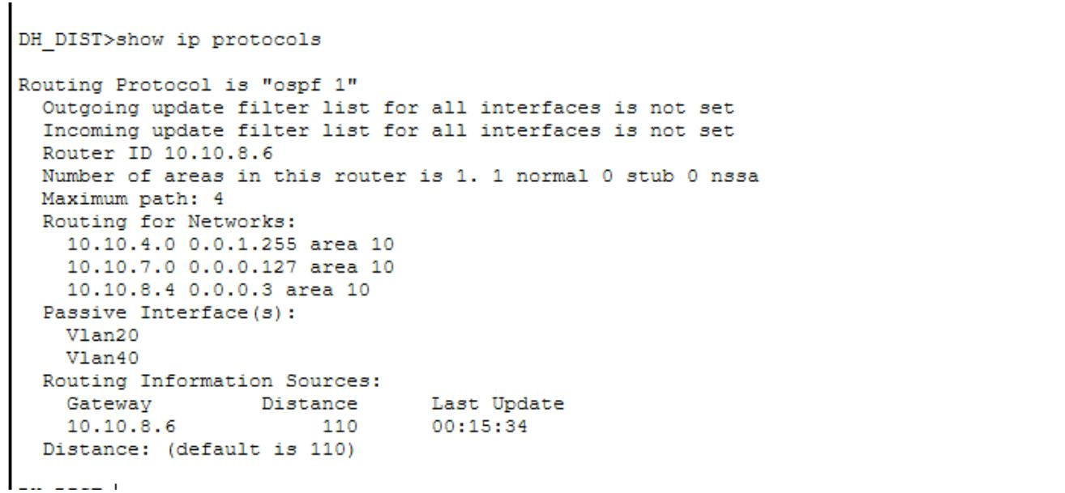

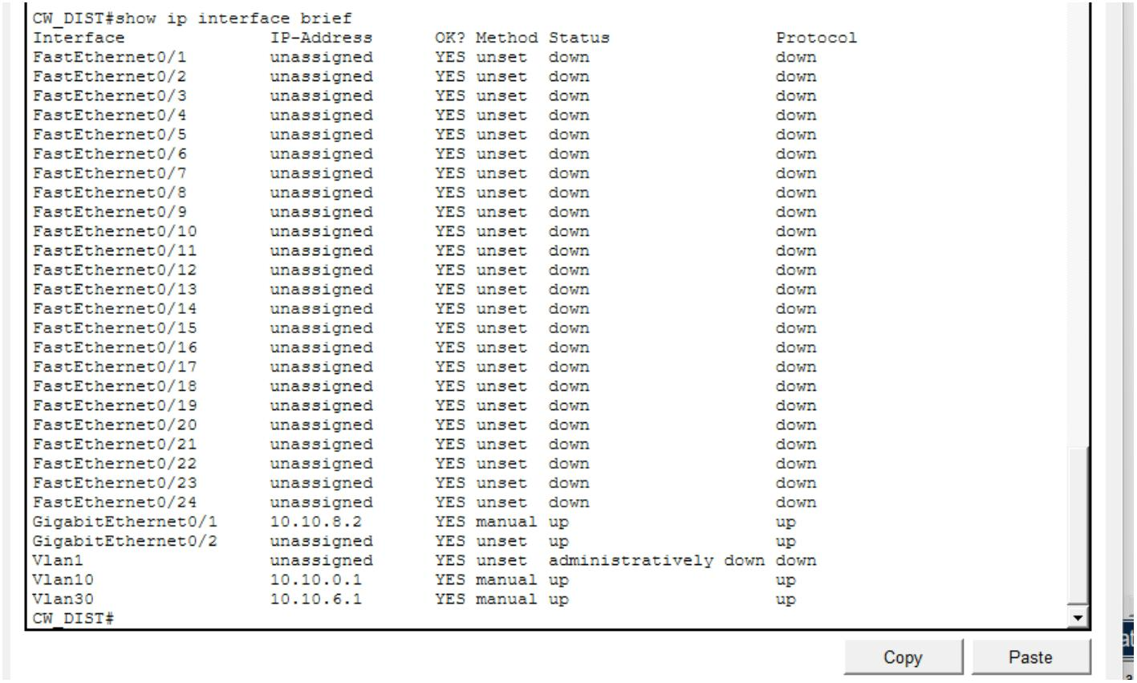
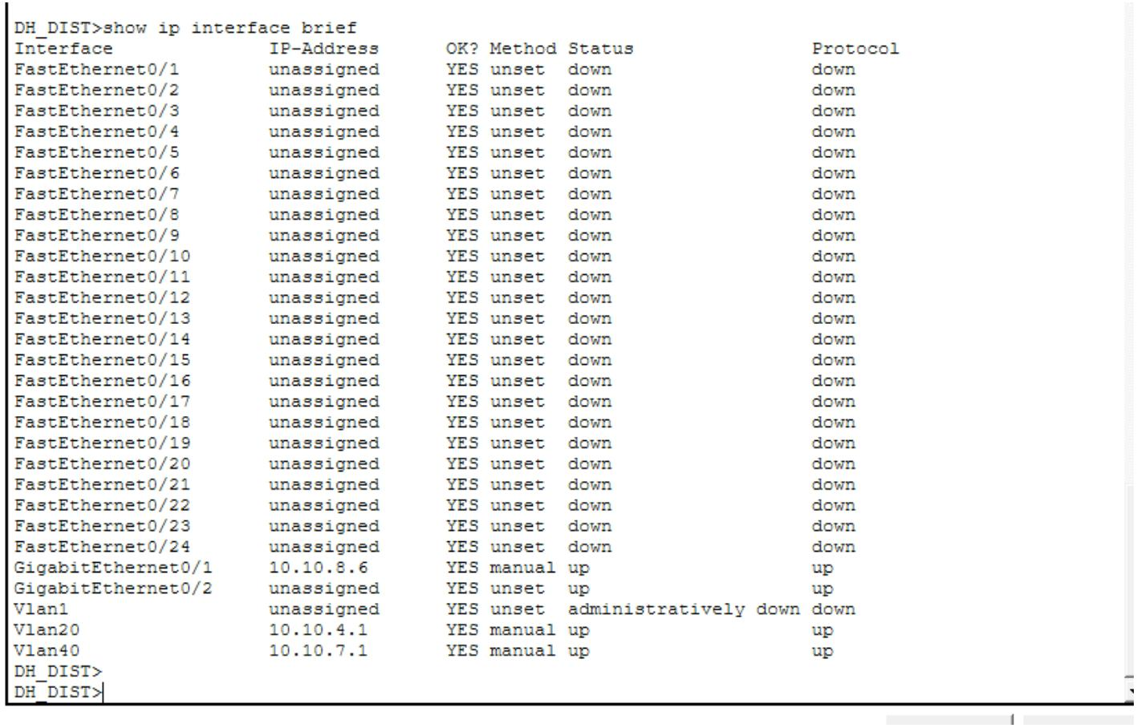

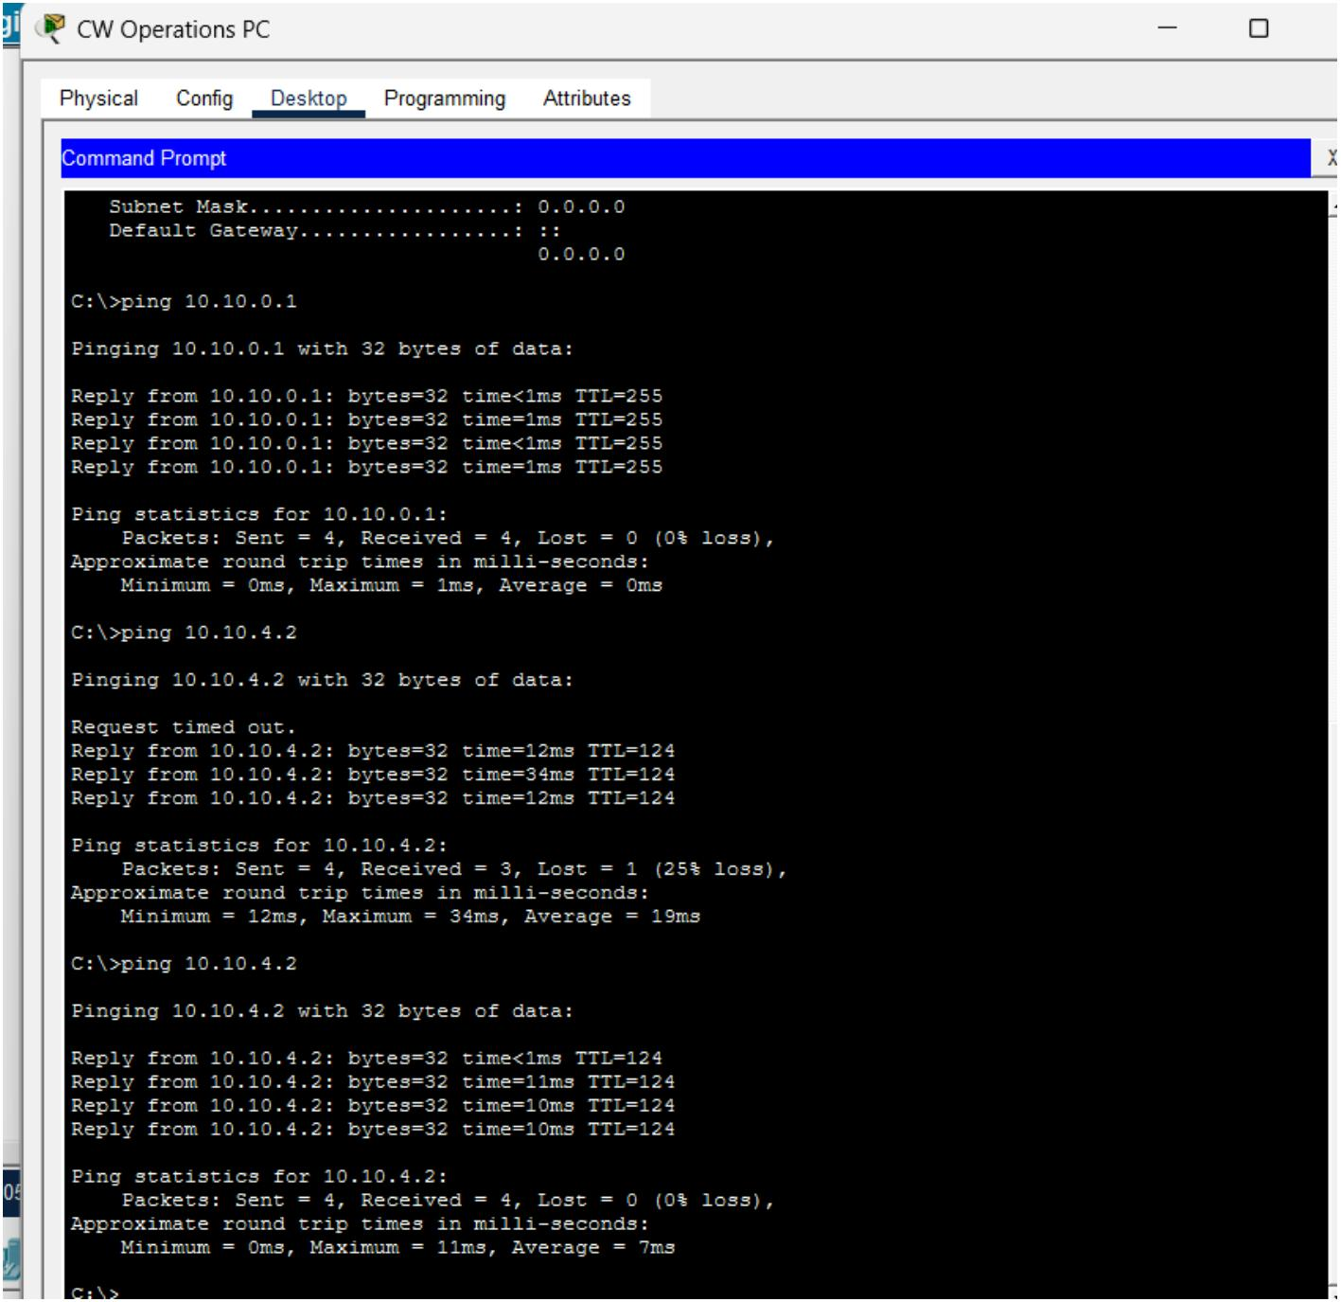

Question 4
